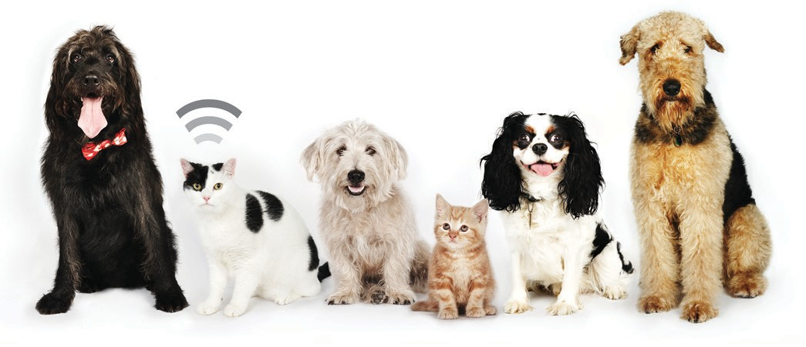

Microchipping is the only tamper-proof, permanent ID that you can give your pets. A microchip, together with PetLink registration, gives your pet a silent voice and gives you peace of mind in case your pet should ever be lost.
Only one of these pets will find it’s way home.
Can you guess which one?

TITLE SUBTITLE
Enter the details of your event here.

[Insert logo sticker here]
Ask us about microchipping your pet. It’s simple and quick. Contact us to schedule your pet’s appointment today.
Facility Name Address
City, State, Zip Phone
Email
Web Address

What more information?

For additional information about PetLink, call us at
(1-877) PETLINK (738-5465 or email us at petlink@petlink.net
© 2020 Datamars, Inc. All rights reserved.
PetLink is a registered trademark of Datamars, Inc.

