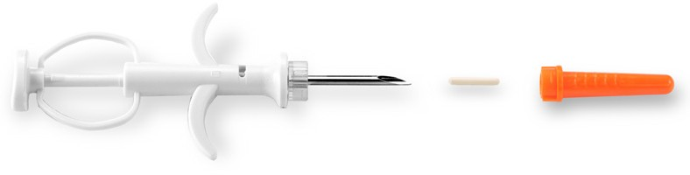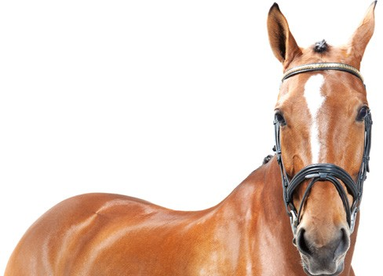Datamars SLIM Microchips

Datamars Equine SLIM Microchips

Sold in boxes of 10 or 25

Includes prepaid registration with PetLink.net

Can be registered as Canine, Feline, Equine, Other

Microchip Material: Polymer Needle Size: 14 gauge
Includes plastic collar tag with laser engraved microchip number

Includes wallet cards for microchip sticker

Includes 25 PetLink.net Customer Brochures

345 West Cummings Park, Woburn, MA 01801 1-877-PETLINK (738-5465)
petlink@petlink.net www.petlink.net
Only sold in boxes of 10

Does not include prepaid registration with PetLink.net

Can only be registered as Equine for a one-time registration fee of $19.99

Microchip Material: Polymer Needle Size: 14 gauge
No collar tags

No wallet cards

Includes one (1) Datamars Veterinary Brochure

